Date access: 2020-03-09

<http://wjw.beijing.gov.cn/wjwh/ztzl/xxgzbd/gzbdyqtb/202001/t20200130_1621742.html>

From 18:00 to 21:00 on January 26, 5 new cases of pneumonia infected with new coronavirus were added in this city

Date: 2020-01-26 Source: Beijing Municipal Health Commission

From 18:00 to 21:00 on January 26, five new cases of pneumonitis infected with new coronavirus were added to the city, of which 2 were close contacts of previously confirmed cases, and all have been sent to designated medical institutions for treatment.

As of 21:00 on January 26, the city has accumulated 68 confirmed cases, including 1 in Dongcheng District, 5 in Xicheng District, 11 in Chaoyang District, 16 in Haidian District, 4 in Fengtai District, 2 in Shijingshan District, and 6 in Tongzhou District. There were 1 case in Shunyi District, 3 cases in Daxing District, 7 cases in Changping District, and 12 cases came from overseas.

**1月26日18时至21时，本市新增5例新型冠状病毒感染的肺炎病例**

日期：2020-01-26 来源：北京市卫生健康委‍

        1月26日18时至21时，本市新增5例新型冠状病毒感染的肺炎病例，其中2名为此前确诊病例的密切接触者，目前均已送至定点医疗机构进行救治。

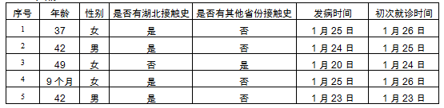

        截至1月26日21时，本市累计确诊病例68例，其中东城区1例、西城区5例、朝阳区11例、海淀区16例、丰台区4例、石景山区2例、通州区6例、顺义区1例、大兴区3例、昌平区7例，外地来京人员12例。